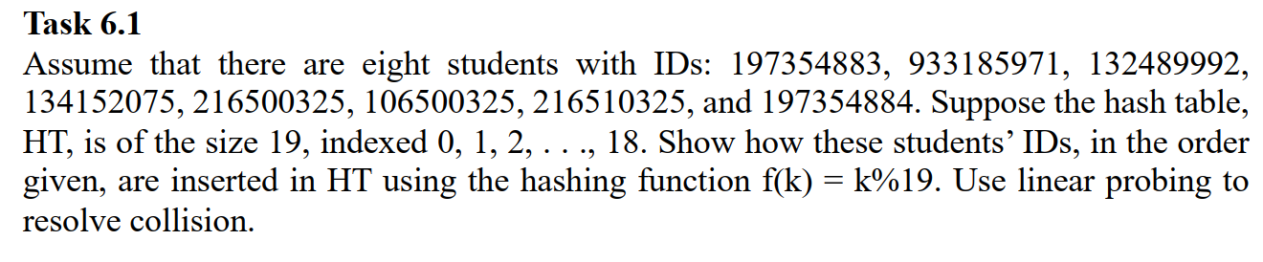  
  
Calculation:

1. **197354883** mod 19 = **2**
2. **933185971** mod 19 = 2, 933185971+1 mod 19 = **3**
3. **132489992** mod 19 = **9**
4. **134152075** mod 19 = **10**
5. **216500325** mod 19 = **18**
6. **106500325** mod 19 = **5**
7. **216510325** mod 19 = 5, 216510325+1 mod 19 = **6**
8. **197354884** mod 19 = 3, 197354884+1 mod 19 = **4**

Corresponding Hash values:

1. h(197354883) = 2
2. h(933185971) = 3
3. h(132489992) = 9
4. h(134152075) = 10
5. h(216500325) = 18
6. h(106500325) = 5
7. h(216510325) = 6
8. h(197354884) = 4

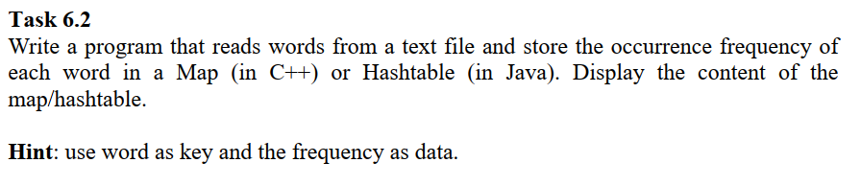

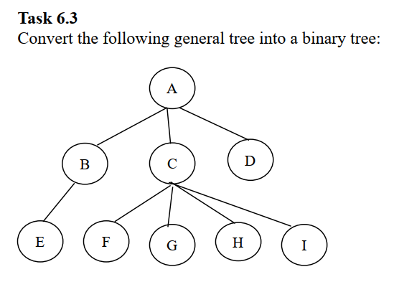

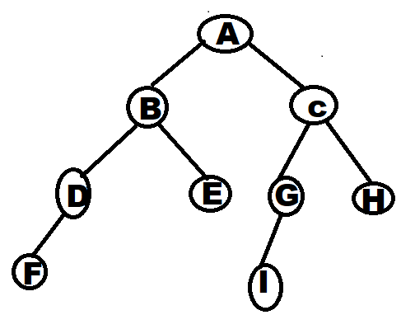

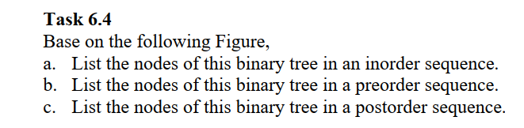

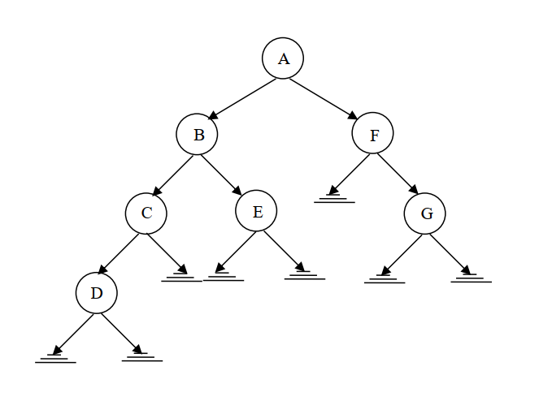

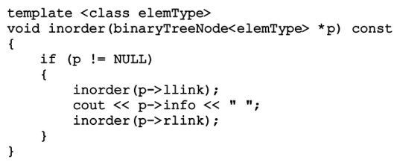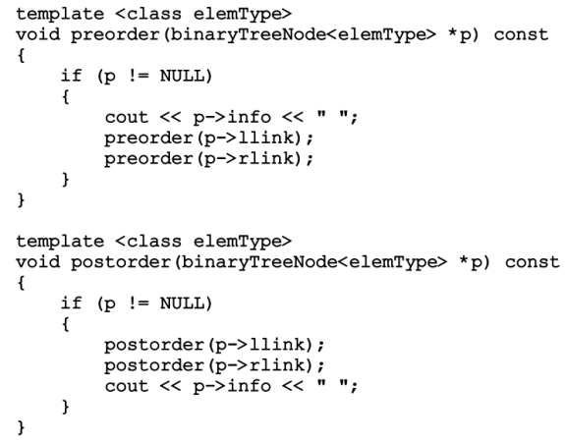

**Inorder Traversal**

**D C B E A F G**

**Pre-Order Traversal**

**A B C D E F G**

**Post-Order Traversal**

**D C E B G F A**